EAST AFRICA INSTITUTE OF PROFESSIONAL COUNSELING
P.O BOX 4770-00200 NAIROBI
TEL: 0708117760/0721-201564
E-mail: info@eaipc.ac.ke
SUMMIT HSE, 3rd FLR, MOI AVENUE
NAIROBI – KENYA

NAIROBI – KENYA
FORM E.A. INST/3
DIPLOMA IN COUNSELING PSYCHOLOGY/GUIDANCE & COUNSELING.
FEES STRUCTURE & GUIDELINES: 2016/2022 ACADEMIC YEAR
01.0 GENERAL RULES
- Tuition fee and all other academic charges are paid before registration or at the beginning of the semester/course
- The Institute shall have the right to preclude any student from attending classes, participating in any academic activity or enjoying other Institute facilities, unless such a student shall have paid to the Institute all fee and other dues, provided the Institute management shall at its discretion exempt any student from this requirement.
- The Institute shall have the right to stop a student who is a debtor to the Institute from registering or sitting for examinations
- The Institute shall have the right to withhold the award of any Certificate on any student until all outstanding fee and other dues are settled with the Institute.
- The Institute shall have the right to withhold examination results from any student who is a debtor to the institute until such debt is paid.
- Fee should be paid through the following institute bank accounts:
1. Equity Bank
Ac. Name : East Africa Institute of Professional Counseling
Ac. No. : 0020195289292
Branch : Fourways Towers, Nairobi

2. Family Bank
Ac. Name : East Africa Institute of Professional Counseling
Ac. No. : 068000000582
Branch : Fourways Towers, Nairobi

3. Mpesa paybill : 678148
Account Number ; EAST AFRICA

ITEM | SEMESTER 1 | SEMESTER 2 | SEMESTER 3 | SEMESTER 4 | SEMESTER5 | SEMESTER 6 | SEMESTER 7
- Tuition Fees | 21,000.00 | 21,000.00 | 21,000.00 | 21,000.00 | 21,000.00 | 21,000.00 | 21,000.00
- Examination Fees | 1,000.00 | 1,000.00 | 1,000.00 | 1,000.00 | 1,000.00 | 1,000.00 | 1,000.00
- Course materials | 1,000.00 | - | - | - | - | - | -
- Student ID | 500.00 | - | - | - | - | - | -
- Research Project | 2,000.00 | - | - | - | - | - | -
- Personal Psychotherapy | 10,000.00 | - | - | - | - | - | -
- Library Fees | 2,500.00 | 2,500.00 | 2,500.00 | 2,500.00 | 2,500.00 | 2,500.00 | 2,500.00
- Caution Money | 2,000.00 | - | - | - | - | - | -
- Field/Academic Trips | - | 1,500.00 | 1,500.00 | 1,500.00 | 1,500.00 | 1,500.00 | 1,500.00
- Practicum supervision | 500 | 500 | 500 | 500 | 500 | 500 | 500
Total | 40,500 | 26,500.00 | 26,500.00 | 26,500.00 | 26,500.00 | 26,500.00 | 26,500.00

Signed:_ 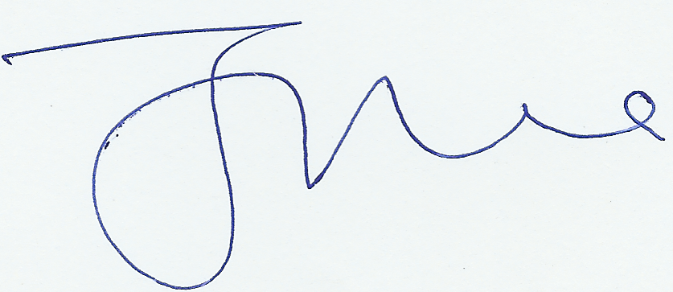

Chairman, BOD

